- Website link Name- Gymsoft || Best Gym Management Software
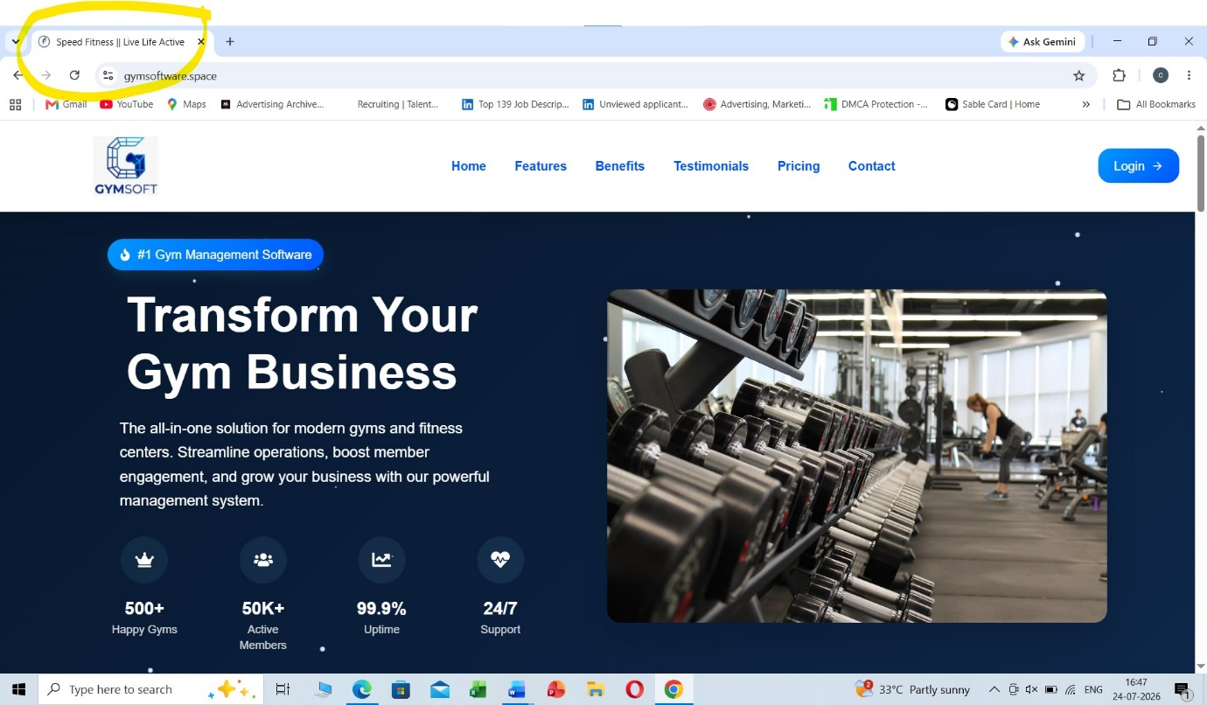
- Change to Gymsoft
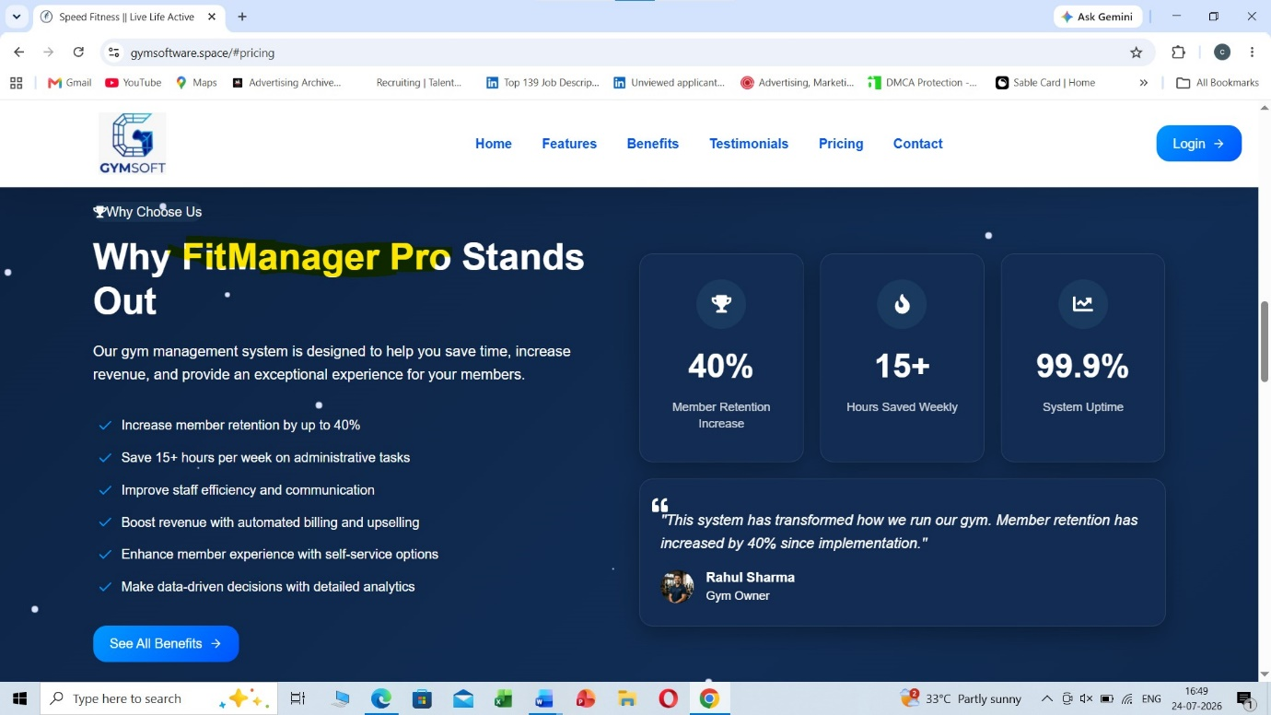
- a) Footer Section – Highlighted sections not required
b) Change Fit manager pro to Gymsoft and also logo
c) Privacy policy Email Id- raj@gymsoftware.space // Name- Gymsoft
d) Terms and conditions- Email Id- raj@gymsoftware.space // Name- Gymsoft
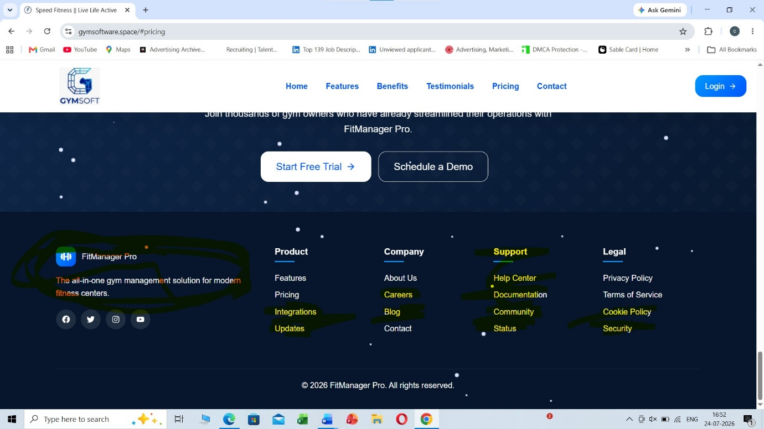
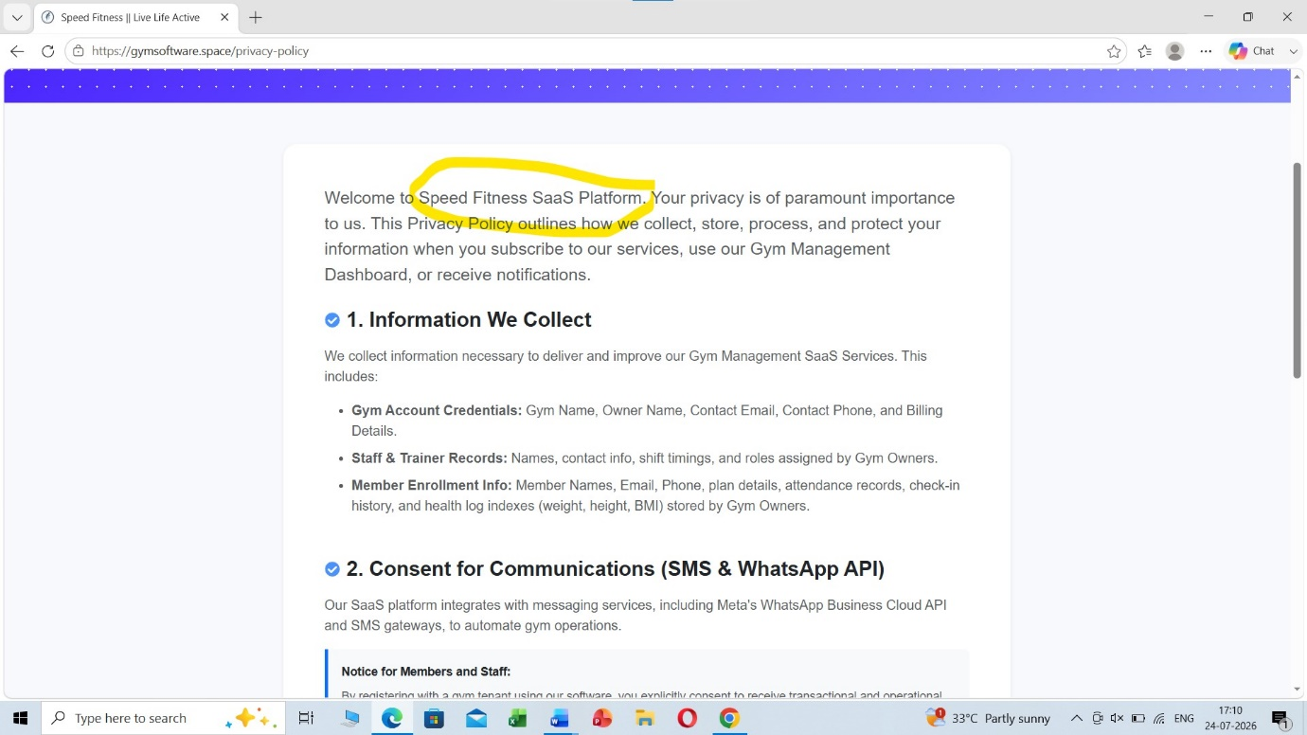
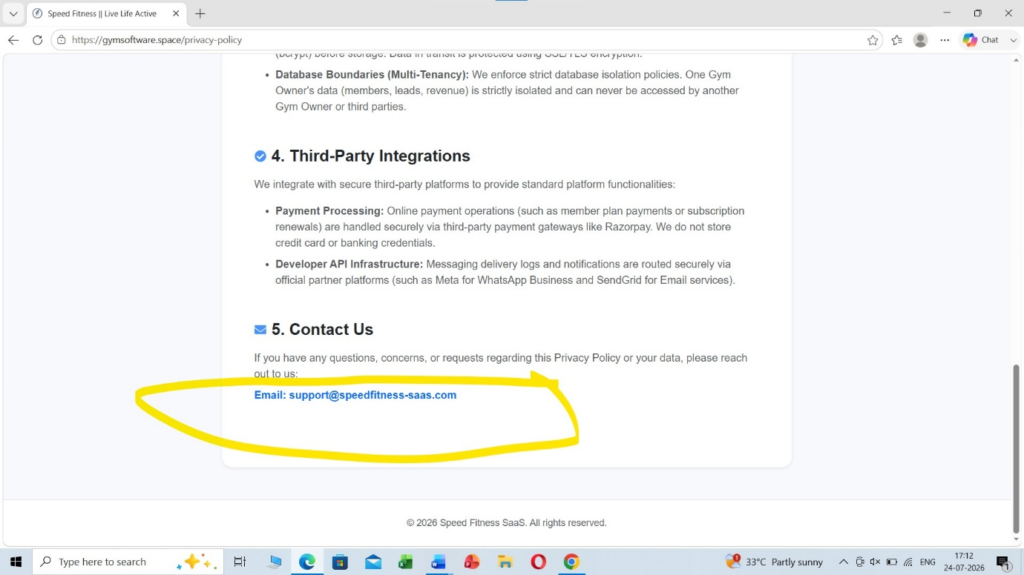

- Contact us-
Gymsoft
DPT 808 B, F-79 & 80
DLF Prime Tower, Pocket F, Okhla Phase 1, Okhla Industrial Estate, South East Delhi, Delhi, 110020
Email Id – support@gymsoftware.space

- Youtube Link- https://www.youtube.com/@Gymsoft-c7e
Insta Link - https://www.instagram.com/gyms0ft/
FB Link- https://www.facebook.com/people/Gymsoft/61591561408740/

